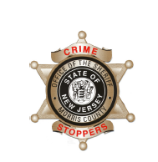
CrimeStoppers
NEEDS YOUR HELP

D

Help us solve this case…
Morris Township

Morris Township Police are investigating a Road Rage incident that left a motorcyclist injured.

On Sunday, August 5, 2018 at approximately 3:15 pm near 435 South Street in Morris Township, a motorcyclist was purposely struck by a vehicle. According to the victim, an unknown male (unknown race) driving what is believed to be a silver 2016-2018 Chevy Cruze, struck the motorcycle causing it to leave the roadway. The driver/victim of the motorcycle suffered an ankle injury and abrasions.

The suspect vehicle left the scene of the accident and may have damage to the passenger side mirror and possibly have scratch marks near the passenger side front fender.

We are asking anyone that may have information to contact
The Morris County Sheriff’s CrimeStoppers at:
www.copcall.org
973-COP-CALL or
Use the free “P3 Tips” app on any mobile device

NO ONE WILL ASK YOUR NAME!

YOU could receive a REWARD up to $1,000.00

