
CrimeStoppers
NEEDS YOUR HELP

D

Help us solve this case…
Mendham Township
On Tuesday, July 17, 2018, between the hours of 1PM and 4PM, Mendham Township had two (2) burglaries to residences in the Cobblefield Drive/Tempe Wick Road and the Washington Valley Road Area. A grey, four door sport utility vehicle is a vehicle of interest in the case; if you saw this vehicle, anything or anyone suspicious during that time frame, please contact CrimeStoppers or the Mendham Township Police dispatch at 973-543-2581. Mendham Township Police is also asking residents in these areas to check their camera systems during these times and let us know if you see anything suspicious.
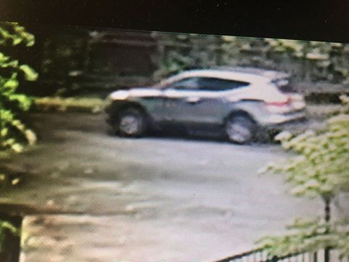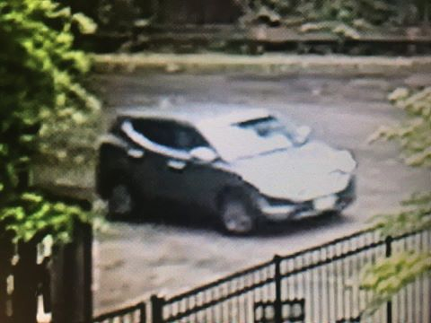

We are asking anyone that may have information to contact
The Morris County Sheriff’s CrimeStoppers at:
www.copcall.org
973-COP-CALL or
Use the free “P3 Tips” app on any mobile device

NO ONE WILL ASK YOUR NAME!
YOU could receive a REWARD up to $1,000.00

