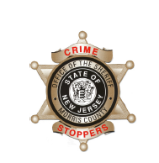
CrimeStoppers
NEEDS YOUR HELP

D

Help us solve this case…
Madison
The Madison Police Department is seeking the public’s assistance regarding a criminal mischief incident that began on March 14, 2019. Unknown actor(s) have spray-painted the below graffiti in approximately 18 locations using various colors throughout the town over the course of 2 or 3 days.
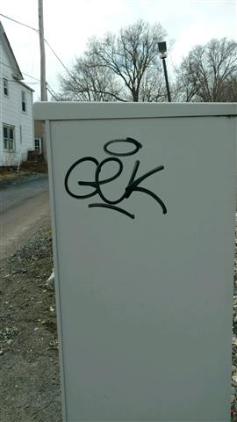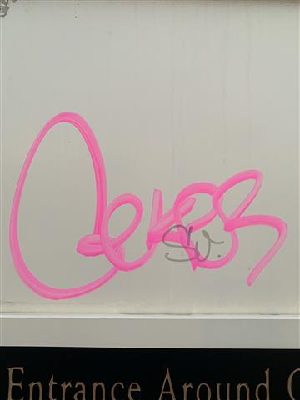
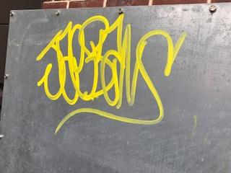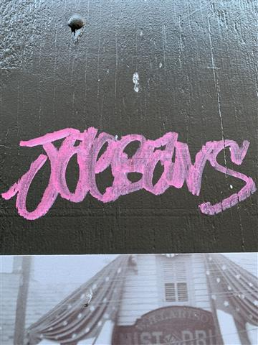
We are asking anyone that may have information to contact The Morris County Sheriff’s CrimeStoppers at: www.copcall.org 973-COP-CALL or Use the free “P3 Tips” app on any mobile device NO ONE WILL ASK YOUR NAME! YOU could receive a REWARD up to $1,000.00

