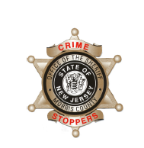
CrimeStoppers
NEEDS YOUR HELP

D

Help us solve this case…
East Hanover
At 12:14 a.m, January 10, 2019, the East Hanover Police Department responded to the Exxon Gas Station located at the corner of River Road and Route 10 on a report of an armed robbery. The attendant reported a male, approximately 5”10” tall, wearing a grey hooded sweatshirt, black pants, and a black mask pointed a handgun at him and demanded money. The attendant handed over an undetermined amount of cash to the suspect. The suspect fled the gas station on foot.
Randolph
Later that morning, at approximately 1:36 a.m., law enforcement officers were dispatched to the 7-11 store, located on South Salem Street in Randolph, on a report of an armed robbery. The store clerk reported that he was working at the counter when a man entered the store, showed a black handgun, and demanded money. After the clerk provided cash to the man, the suspect fled on foot with the cash. The assailant is described as a black male, thin build, carrying a black handgun. He was wearing black pants with a white checkered pattern on the legs, a grey hoodie sweatshirt, black gloves, and a ski mask.
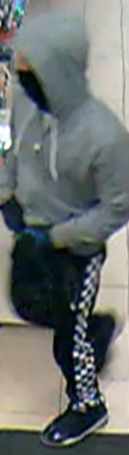
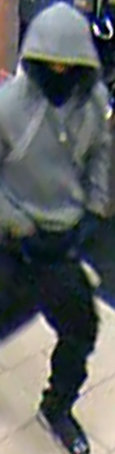
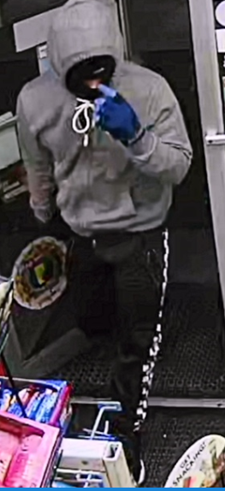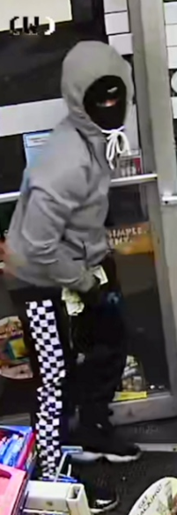
East Hanover East Hanover Randolph Randolph
We are asking anyone that may have information to contact The Morris County Sheriff’s CrimeStoppers at: www.copcall.org 973-COP-CALL or Use the free “P3 Tips” app on any mobile device NO ONE WILL ASK YOUR NAME! YOU could receive a REWARD up to $1,000.00

