
CrimeStoppers
NEEDS YOUR HELP

D

Help us solve this case…
Morris Plains
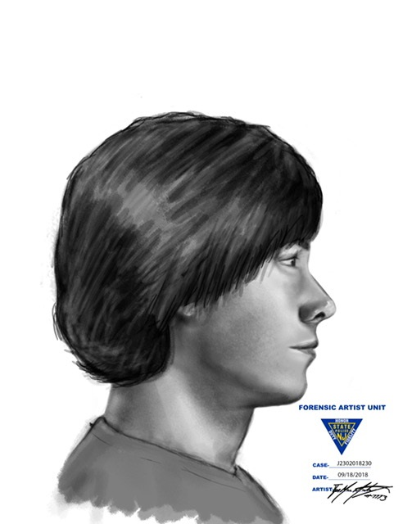
The Morris Plains Police Department is currently investigating an act of lewdness that occurred in the parking lot of the Stop & Shop Supermarket located at 245 Littleton Road near the intersection of Route 10. On Sunday, September 16th, 2018, at approximately 1105am, a gold colored vehicle parked next to the victim. As the victim began pulling out of the parking spot, the driver of the gold vehicle exposed his penis and began masturbating while seated in his car. The victim described the suspect’s vehicle as an older, gold colored car. The suspect was described as a white male in his 20's with dark hair that has a curl at the bottom.

We are asking for the public's help with identifying the vehicle and its driver or anyone who may have observed anything.
We are asking anyone that may have information to contact
The Morris County Sheriff’s CrimeStoppers at: www.copcall.org
973-COP-CALL or
Use the free “P3 Tips” app on any mobile device

NO ONE WILL ASK YOUR NAME!

YOU could receive a REWARD up to $1,000.00

