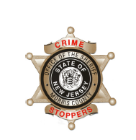
CrimeStoppers
NEEDS YOUR HELP

D

Help us solve this case…
Denville Township Police Department
The Denville Township Police are seeking help on identifying the person below in regards to a motor vehicle theft and several car burglaries.
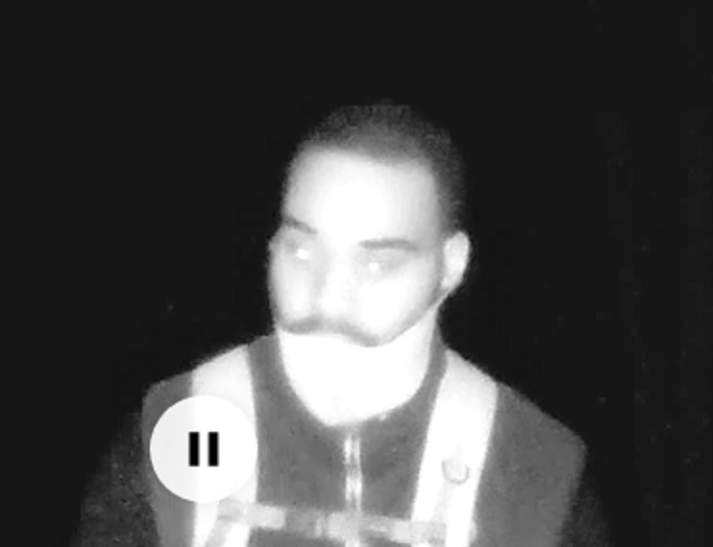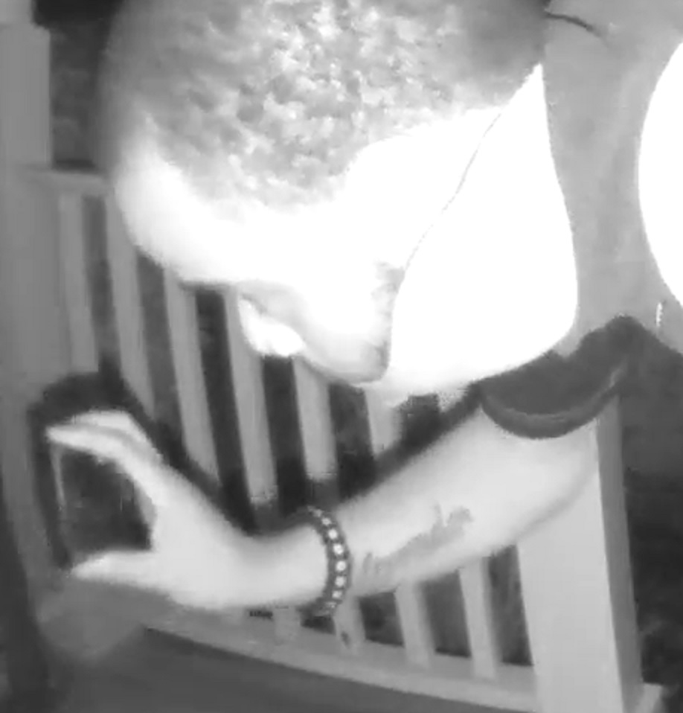
We are asking anyone that may have information to contact
The Morris County Sheriff’s CrimeStoppers at:
www.copcall.org
973-COP-CALL or
Use the free “P3 Tips” app on any mobile device
NO ONE WILL ASK YOUR NAME!
YOU could receive a REWARD up to $1,000.00

