
CrimeStoppers
NEEDS YOUR HELP

D

Help us solve this case…
Morris Township Police Department
We are seeking assistance in identifying the below pictured male and vehicle in regards to numerous package thefts that occurred on November 1, 2018, in the late afternoon hours. The male would empty the box from one residence and then use that empty box to replace a package he would steal from the next residence.
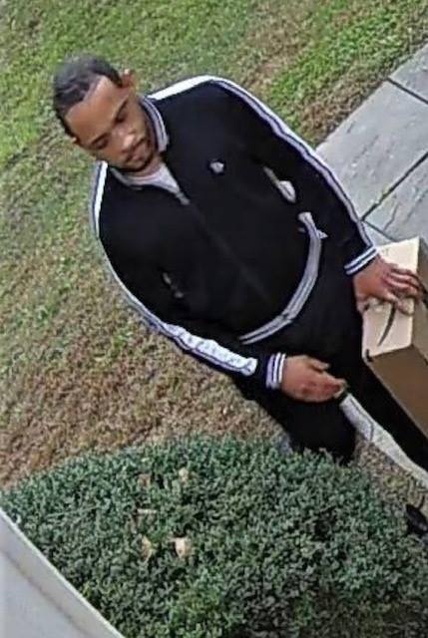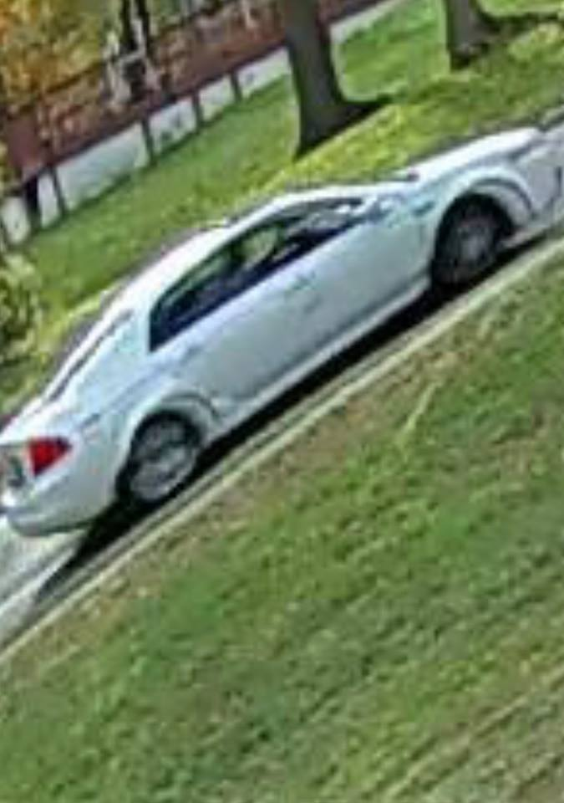
The police ask that anyone that may have information should contact the
Morris County Sheriff’s CrimeStoppers Program at:
www.copcall.org
973-COP-CALL or
by using the free “P3 Tips” app on any mobile device
You will remain completely anonymous

