
CrimeStoppers
NEEDS YOUR HELP

D

Help us solve this case…
MORRIS TOWNSHIP
The Morris Township Police are currently investigating a Burglary, which occurred on Frederick Place on Saturday, July 29, 2018 at approximately 8:15 pm. The unknown suspect was armed with a handgun and fired one (1) round into the floor of the residence. It is believed that the suspect was shooting at the homeowner’s dog. No one was injured and the home was occupied by the resident at the time of the incident. There is no immediate danger to the public and it is an isolated incident.
The suspect is described as a black male, athletic build, approximately 5-6” to 5-8”, wearing a black hooded sweatshirt, dark colored pants, and wearing a black backpack. The suspect’s hair is described as short on the sides and having one inch twisted braids on top. The age of the suspect was approximated to be late 20’s to early 30’s.
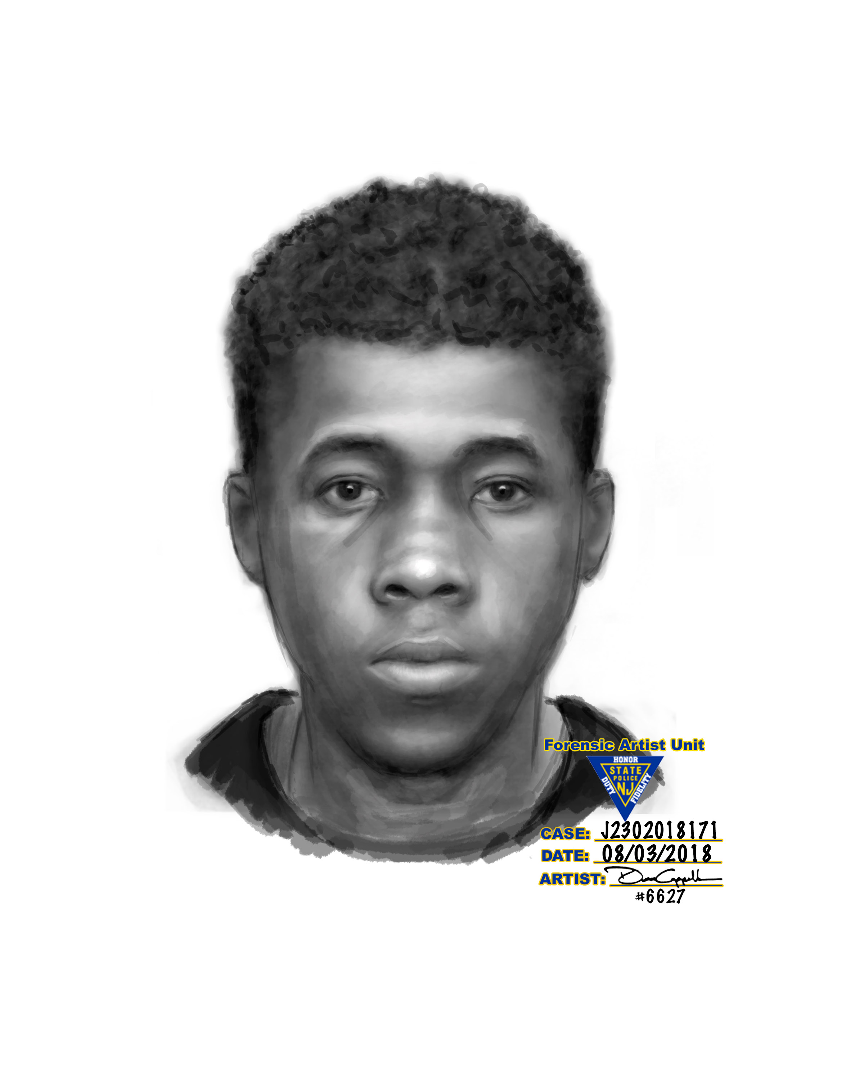
We are asking anyone that may have information to contact
The Morris County Sheriff’s CrimeStoppers at:
www.copcall.org
973-COP-CALL or
Use the free “P3 Tips” app on any mobile device
NO ONE WILL ASK YOUR NAME!
YOU could receive a REWARD up to $1,000.00

