CrimeStoppers
NEEDS YOUR HELP

D

Help us solve this case…
Morris Plains
On Saturday, May 11, 2019, the operator of a silver or white DODGE RAM pickup truck committed a theft in Morris Plains. According to a witness, the pickup arrived near the parking garage of The Highlands in Morris Plains, located at 40 East Hanover Avenue, and began taking 6-10 unsecured bicycles from the bicycle rack. These bicycles, belonging to both children and adults, were then loaded into the pickup truck the suspect was operating before he drove away. Further description of the suspect vehicle includes a 4-door pickup with black rims, a dark bug deflector on the front hood and a bed cover (as seen in the image). The suspect is described as possibly a white male in his 40's or 50's. The vehicle is believed to have fled onto Speedwell Avenue in an unknown direction.
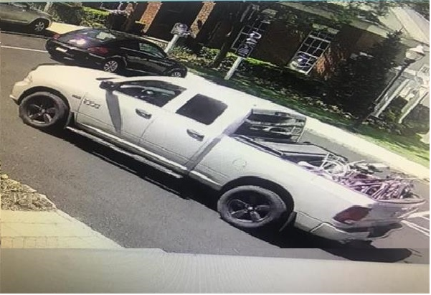
We are asking anyone that may have information to contact
The Morris County Sheriff’s CrimeStoppers at: www.copcall.org
973-COP-CALL or
Use the free “P3 Tips” app on any mobile device
NO ONE WILL ASK YOUR NAME!
YOU could receive a REWARD up to $1,000.00

