Kansas Crime Stoppers Scholastic Conference
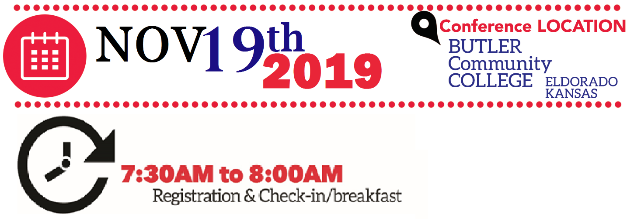

8:OOAM | Welcome & Conference Overview
8:15AM | David Crook (Motivational Speaker)
9:20AM | Break
9:30AM | Bullying Scenarios (What do you do?)

10:30AM Break
10:40AM Affecting Change in our schools Workshop
(Kurt Spivey, SRO El Dorado Schools)
11 :45AM Lunch (Provided)
12:30PM How do I start Crime Stoppers in my School?
1:30PM Follow-up / Question & Answer Session
2:OOPM Dismissal

