Item # 8

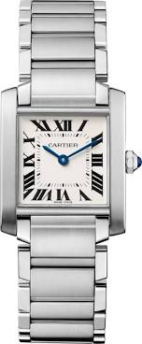

Item # 9

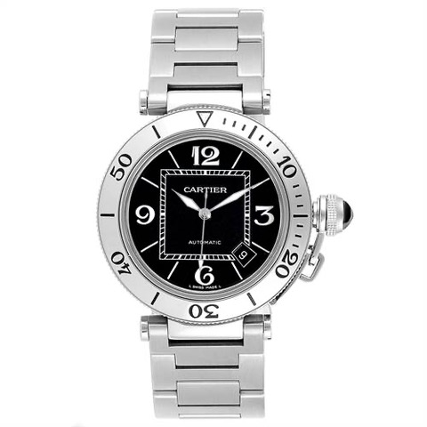

Item # 10

Item # 11

Item # 12

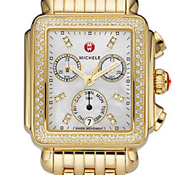

Item# 13

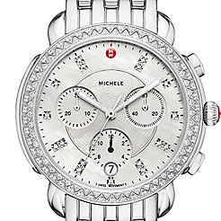

Actual watch has no diamonds in bezel