Item # 14 & 18 (2 watches in different colors)
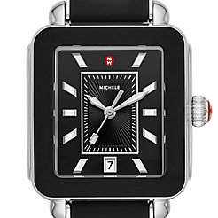michele in brown and round one in navy blue

No Photo Items # 15, 16, 17 or 19
Item # 20
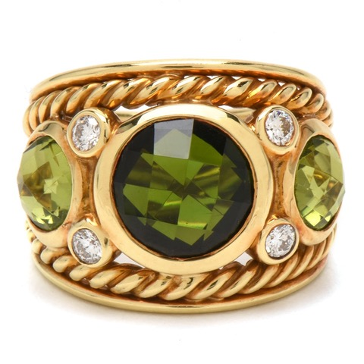

Item # 21
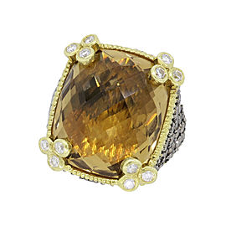
Judith Ripka; Top stone with prongs matching bottom ring in gold. No gold frame around brown stone.
Item # 22

