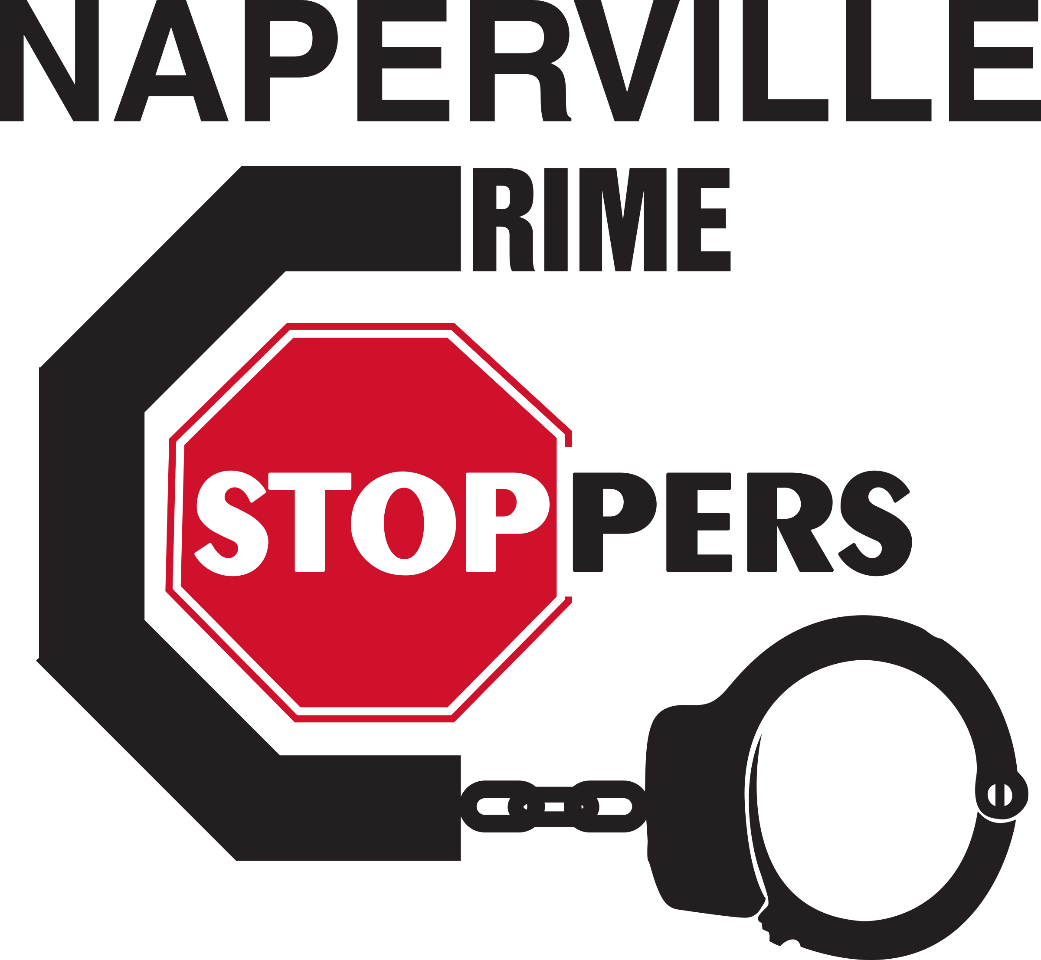
Please take a decal and place it on your front door or window as a crime deterrent. Your house may be chosen at random to receive a free lunch for two at Quigley’s Irish Pub, 43 E. Jefferson Ave., Naperville. Two houses will be chosen. One in November and one in December.
Remember, Crime Stoppers just wants your crime tip, NOT your name!
Remain Anonymous
Cash Rewards up to $1000 CASH
630-420-6731

